Third Grade Supply List

C:\Users\mhedeman\AppData\Local\Microsoft\Windows\Temporary Internet Files\Content.IE5\214FOCU3\MC900232723[1].wmf

Dear Parents/Guardians,

Welcome to Third Grade! Listed below are the supplies your child will need for school. Please note that these items should be replaced as needed throughout the school year. Please label all supplies with your child’s name!

* 2 **plastic** folders for in class (red and yellow)
* Blue **plastic** folder for homework (hole-punched)
* 1 ½ inch 3 ring binder with inside pockets (please no larger)
* Headphones in a gallon sized plastic bag
* 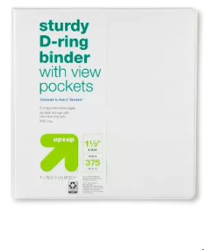1 spiral bound wide ruled 150+ page notebook
* 1 pack of colored pencils (24 count or less)
* 12 sharpened pencils
* 2 large Elmer’s glue sticks
* 1 large pencil case
* 4 yellow highlighters
* 8 thin tipped Expo markers
* 1 Expo eraser or clean sock
* 1 box of tissues (to be shared with the class)
* Last names A-M: I bottle of hand sanitizer (to be shared with the class)
* Last names N-Z: 1 box of Ziplock baggies (gallon or sandwich sized)
* **Optional:** fine tip markers (10 count or less)

***Please note: Your child’s backpack should be able to hold their laptop case and binder. They will be bringing both back and forth each day.

Have a wonderful summer! We will see you at the end of August!

The Third Grade Team J